*ASSIGNMENT*

**COMMUNICATION SKILLS**

1. Explain in diagram the communication processes

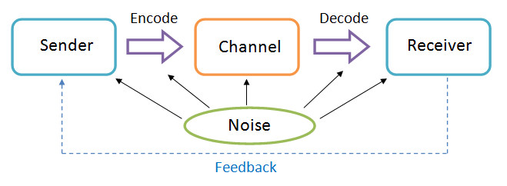

**Sender**

The sender generates the message and conveys it to the receiver. He is the source and the one who starts the communication.

**Message**

It is the idea, information, view and fact that is generated by the sender and is then intended to be communicated further.

**Encoding**

The message generated by the sender is encoded symbolically such as in the form of words, pictures and gestures before it is being conveyed.

**Channel**

It is the manner in which the encoded message is transmitted. The message may be transmitted orally or in writing. The medium of communication includes internet, post and many more.

**Decoding**

It is the process of converting the symbols encoded by the sender. After decoding the message is received by the receiver.

**Receiver**

He is the person who is last in the chain and for whom the message was sent by the sender.

**Feedback**

Once the receiver confirms to the sender that he has received he message and understood it, the process of communication is complete.

**Noises**

It refers to any obstruction that is caused by the sender, message or receiver during the process of communication. For example, bad connection, poor understanding of message, faulty encoding among others.

1. *Differentiate oral communication and written communication*

**Written communication**

Refers to process of conveying a message through the written symbols such as letters, journals, the electronic mail among other.

**Oral communication**

This communication using word of mouth. It includes individuals conversing with each other, be it direct conversation or telephonic conversation.

***CAT1***

**Identify barriers to communication and how to overcome**

1. **Psychological Barriers**

The psychological condition of the receiver will power how the message is received. Stress management is a significant personal skill that affects our interpersonal relationship. For example, anger is a psychological barrier to communication. When are angry, it is simple to say things that we may regret afterwards ad also misunderstand what others are saying.

1. **Language Barriers**

Language and linguistic aptitude may act as a barrier to communication. However, even when communicating a similar language, the terms used in a message may act as a barrier if it is not easy to understand by the receiver.

1. **Attitudinal Barriers**

Attitudinal barriers are perceptions that stop people from communicating well. It may affect from personal conflict, poor management and lack of motivation.

1. **Physical Barrier**

Are physical things that get in the way of communicating process. A basic physical distraction can be the environment the room may be too cold or too hot, or the chairs can be uncomfortable.

1. **Physiological Barriers**

Physiological barriers are related with the limitations of the human body and the human mind such as poor eyesight, hearing difficulties, personal discomfort among others.

How to overcome communication barrier

1.**Have a positive attitude about communication**. Defensiveness interferes with communication.

2.**Beware of language, message and tone**. The sender should ensure that the message should be structured in clear and simple language. The tone of the message should not harm the feelings of the receiver.

3**.Emotional state**. During one should make effective use of body language. He/she should not show their emotions while communication as the receiver might misinterpret the message being delivered.

4.**Seek therapy and medical help for physical disabilities**. Speech and hearing impairments can be treated with therapy, surgeries or mechanical aids. Improve memory by playing games and other actives that improve memory.

5.**Focus on people’s abilities and capabilities and not their disabilities**. Start from the assumption that everyone can participate and make their own choices.

***CAT2***

**Give objectives of effective communication**

1. Building awareness
2. Providing information or educating
3. Creating interest
4. Motivating people
5. Promoting the brand, product or service
6. Organizing resources
7. Increasing efficiency
8. Job satisfaction of the employees
9. Offering better coordination
10. Harmonious relationship between management and workers